**Microcontroller-Based Voting System for Institutional Applications**

**A Mini Project Report**

***Submitted for***

**19EC552 – MICROPROCESSORS LABORATORY**

***By***

**Seenivasan M (Roll No.22BEC180)**

**Sutharsan S (Roll No.22BEC185)**

**III Year B.E ECE C**

**Department of Electronics and Communication Engineering**

**Academic Year 2024 - 2025**



**Mepco Schlenk Engineering College**

**(An Autonomous Institution Affiliated to Anna University, Chennai)**

**Mepco Engineering College (PO), Sivakasi – 626 005**

**Virudhunagar (District), Tamil Nadu**



**November 2024TABLE OF CONTENTS**

|  |  |  |
| --- | --- | --- |
| **S.No.** | **CONTENTS** | **Page No.** |
| 1 | Introduction | 3 |
| 2 | Problem Statement | 3 |
| 3 | Objectives | 3 |
| 4. | Circuit Explanation | 3 |
| 5. | Components Used | 4 |
| 6. | Microcontroller (PIC16F877A) Overview | 4 |
| 7. | Circuit Simulation and Results (Proteus) | 5 |
| 8. | Conclusion | 6 |
| 9. | Future Enhancements | 6 |

**Title: ElectraVote: Microcontroller-Based Voting System for Institutional Applications**

**1. Introduction**

This project introduces a secure, microcontroller-driven voting system for institutional environments such as schools and colleges, built to offer simplicity, reliability, and accuracy in voting processes. Given the growing need for efficient electronic voting methods, this project aims to develop a voting system that is straightforward to operate and capable of accurately capturing votes for candidates. The prototype utilizes an PIC16F877A microcontroller to handle voting inputs, display results on an LCD, and manage the entire voting session autonomously, minimizing human intervention.

**2. Problem Statement**

The need for a reliable, low-cost voting system within educational institutions and similar small-scale environments has been longstanding. Traditional voting methods can be inefficient and time-consuming, often prone to human error or delays in result tallying. Our project addresses this by automating the process and using a microcontroller-based design to provide a seamless solution that captures and displays results instantly, streamlining the overall voting experience.

**3. Objectives**

* To design a secure and user-friendly electronic voting system using the PIC microcontroller.
* To provide real-time feedback on votes and dynamically display election results.
* To offer a scalable voting system with reset and tally functionalities that can be adapted to institutional needs.
* To ensure simplicity in operation, making the system suitable for a wide audience without extensive training.

**4. Circuit Explanation**

The circuit is designed to accept votes from users via push-button switches, count these votes using the PIC microcontroller, and display the results on a 16x2 LCD screen. The main components and their functions are described below:

**1. Power Supply Section (IC1 7805 Voltage Regulator)**

* **IC1 (7805)**: The circuit is powered by a 9V DC source (connected at CON1). The voltage regulator IC1 (7805) converts the input 9V to a stable 5V output, which is essential for powering the PIC16F877A microcontroller and the other components.
* **Capacitors (C1 and C2)**: The capacitors (C1 = 100µF and C2 = 10µF) are used for filtering to stabilize the power supply by smoothing out any fluctuations.
* **Indicator LED (LED5)**: The power indicator LED (LED5) confirms that the circuit is powered on, connected in series with a 220-ohm resistor (R1) to limit current.

**2. Microcontroller (PIC16F877A) Core**

* **PIC16F877A**: Acts as the central processing unit, responsible for reading inputs from switches, incrementing vote counters, and displaying results.
* **XTAL1 and XTAL2 (8 MHz Crystal Oscillator)**: The crystal oscillator and associated capacitors (C3 and C4, both 22pF) provide a stable clock source for the microcontroller, ensuring consistent timing operations.
* **Reset Button:** The reset button allows the microcontroller to be reset manually, initializing the system for a fresh start.

**3. Input Section (Voting Switches and Resistors)**

* **Switches (S1 to S6)**: Four push-button switches are provided for vote casting. Each switch represents a different candidate/option:
  + **S1**: Casts a vote for the first party.
  + **S2**: Casts a vote for the second party.
  + **S3**: Casts a vote for the third party.
  + **S4**: Casts a vote for the fourth party.
  + **S5**: Casts a vote for the fifth party.
  + **S6**: Casts a vote for the sixth party.
  + **S7**: Used to display the voting results.
* **Pull-Down Resistors (10KΩ)**: These resistors ensure that the input pins connected to the switches are pulled to a low state when the switches are not pressed, preventing false triggering.

**4. Visual Indicators (LEDs)**

* **LEDs (LED1 to LED6)**: Each push-button switch has an associated LED (LED1 for S1, LED2 for S2, etc.) to indicate that a vote has been cast. These LEDs light up when their respective switches are pressed, providing visual feedback.
* **Current-Limiting Resistors (220Ω)**: Connected in series with the LEDs to limit current flow and protect them from damage.

**5. LCD Display (16x2 LCD)**

* **LCD1 (16x2)**: The 16x2 LCD is used to display the status messages, "Thank You" notes after a vote is cast, and final voting results. It is connected to the microcontroller via data pins D4 to D7 and control pins (RS, RW, and EN).
* **Contrast Control (VR1)**: A 10KΩ variable resistor (potentiometer) is used to adjust the contrast of the LCD display for clear visibility.
* **Power Connections (Vss, VDD)**: Vss is connected to ground, and VDD is connected to the 5V power supply.
* **Enable and Control Pins**: The RS, RW (set to ground for write mode), and EN pins are connected to respective microcontroller ports to control the data transfer.

**Circuit Operation**:

1. **Initialization**: The PIC microcontroller is programmed to display a welcome message on the LCD and wait for input.
2. **Voting Process**: When a button (S1-S6) is pressed, the microcontroller detects the input, increments the corresponding candidate's vote count, and displays a "Thank You" message.
3. **Results Display**: When a designated result button (e.g., S7) is pressed, the microcontroller processes the votes and displays the total votes for each candidate on the LCD. The highest number of votes determines the winner, and the results can be shown in a scrolling format if necessary.

**5. Components Used**

The key components in this project include:

* **Microcontroller**: PIC16F877A.
* **LCD Display**: 16x2 character LCD.
* **Push-Button Switches**: 6 for voting, 1 for displaying results.
* **Resistors**: 10kΩ for pull-down purposes.
* **Voltage Regulator**: IC 7805 for stable 5V output.
* **Capacitors**: 100µF and 10µF for power line stabilization.
* **LEDs**: Optional for indicating a vote has been cast.

These components collectively contribute to the system’s functionality, providing robust, real-time interaction and display management.

**6. Microcontroller (PIC16F877A) Overview**

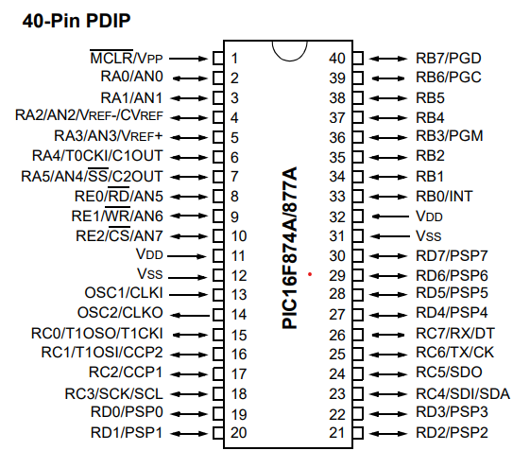

Figure 1 PIC16F877A Pin Diagram

PIC microcontrollers are popular in embedded systems for their simplicity, flexibility, and powerful processing capabilities. For this project, the **PIC16F877A** microcontroller is used, known for its:

* **High-performance RISC CPU**.
* **40 pins**, offering a sufficient number of I/O ports.
* **Integrated features** such as ADC, USART, timers, and LCD interfacing support.

**Key Features of PIC16F877A**:

* 368 bytes of RAM and 256 bytes of EEPROM.
* 33 I/O pins divided into PORTA, PORTB, PORTC, PORTD, and PORTE.
* 8-channel 10-bit ADC for analog inputs.
* PWM modules for control systems.

**Explanation of PIC16F877A Pins**

* **PORTA (RA0 - RA5)**: Analog and digital I/O pins.
* **PORTB (RB0 - RB7)**: 8-bit bidirectional I/O port, often used for switch and button inputs.
* **PORTC (RC0 - RC7)**: Includes UART communication lines; ideal for LCD interfacing.
* **PORTD (RD0 - RD7)**: Primarily used for data communication; connected to the data pins of an LCD.
* **PORTE (RE0 - RE2)**: 3-bit port used for additional inputs or control signals.

**Important Pins for the Project**:

* **Pin 1 (MCLR)**: Master clear/reset; connected to a pull-up resistor for stability.
* **Pins 11 and 32 (VDD)**: Power supply pins.
* **Pins 12 and 31 (VSS)**: Ground connections.
* **Pins 19-22 (PORTD)**: Connected to the LCD data lines (D4-D7).
* **Pins 23 and 24 (PORTD)**: Connected to RS (Register Select) and EN (Enable) pins of the LCD for control.

**7. Circuit Simulation and Results (Proteus)**

In the Proteus simulation environment, This Voting System demonstrates smooth operation, accurately registering votes and displaying results. The simulation setup in Proteus includes the PIC16F877A microcontroller interfaced with the LCD and switches, providing a virtual demonstration of the voting process. This simulation validates the system's design and ensures all functionalities work as intended.

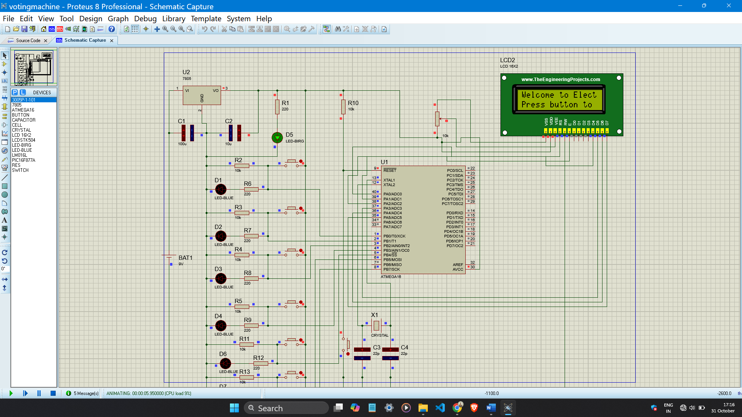

Figure 2 Proteus Simulation for 6 candidates – Welcome message on LCD Display.

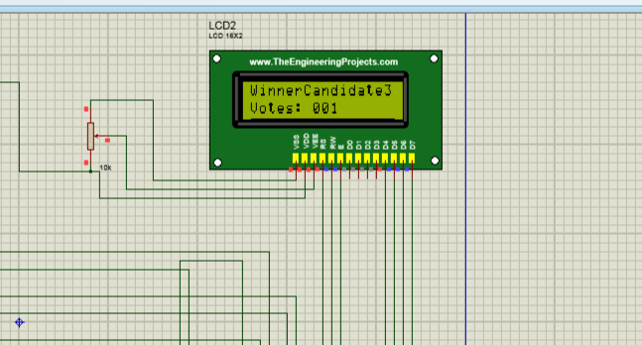

Figure 3 Proteus Simulation for 6 candidates - LCD Display after Voting

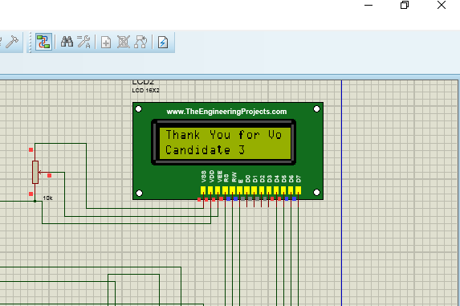

Figure 4 Proteus Simulation for 6 candidates - Result Display

**Key observations from the simulation:**

* Vote Counting: Each switch press incremented the respective candidate's count.
* Real-Time Feedback: The LCD displayed a thank-you message after each vote.
* Result Display: Upon pressing the result button, the LCD accurately displayed the winner or declared a tie.

**8. Conclusion**

ElectraVote has successfully demonstrated the feasibility of an electronic voting system built for institutional use, showcasing accuracy, reliability, and efficiency. The use of the ATmega16A microcontroller in conjunction with a simple circuit setup provides a robust solution, ensuring reliable vote capture, confirmation messages, and result display. The project demonstrates a scalable prototype, suitable for further development into larger-scale applications.

**9. Future Enhancements**

While ElectraVote fulfills the basic requirements of an electronic voting system, several enhancements could increase its capabilities:

* Enhanced Security: Incorporating PIN or biometric authentication to restrict unauthorized voting.
* Data Storage: Adding external storage options for retaining vote records post-election.
* Remote Access and Reporting: Enabling the system to report results to an external server or database.

These enhancements could extend the utility of ElectraVote, making it more versatile and applicable across varied environments.